**Assignment 1- E-Business Prototype Report**

**1. Introduction**

**a. Introduction of the business scenario and objectives of the solution.**

DesiWear was established in 2018 and is a leading retail clothing store with a focus on Pakistan's traditional wear. Over the years, the company has reaped the rewards of providing excellent customer service which is no surprise they are recognized as one of the leading players in the retail clothing sector. However, there has been a realization from the company’s leadership that the retail landscape is constantly evolving, and as such it has become very competitive, which calls for new ways of conducting business if they are to continue leading and remain in Business. The company has a new strategic plan to launch an online retail store by 2024 and that will enable it to extend its customer reach and adapt to the evolving retail landscape. The new strategic intent encompasses a comprehensive online strategy with several focus areas with the aim to address some of the challenges that may hinder the company’s growth if they were to be left unattended. To ensure seamless customer service while the company transitioned from a brick-and-mortar setup to an online store, digital transformation is one of the focus areas that will be undertaken to address this dimension. It is envisaged that once the online presence is in effect, customer volumes will increase, thus an efficient inventory and Order management process will be put in place. Hence this (Inventory and Order management) dimension is also another key focus area for the new strategy.

Once the company is online, management will be faced with the responsibility of ensuring that it keeps strong relationships with all its customers. Therefore, establishing an effective Customer Relationship Management system is mandatory. Following that DesiWear prides itself on excellent customer experience, the online version of the store exhibits a user-friendly online experience that aligns with the culture and commitment of the company which makes it unique and sets it apart from its competitors.

There is an aspiration to keep engaging current and new customers using online means, therefore integrating with social media platforms is another focus area which is also aimed at enhancing marketing initiatives of the company. To improve customer reach and visibility, the company will embark on a strategy to optimize search engines so that it is easily noticed and improve organic traffic with less effort towards paid-for traffic.

DesiWear is also alive to the fact that even if it were to achieve all the objectives of the above-mentioned focus areas, it would be worthless without having seamless access and convenience to the platform. Hence this is another area of concern.

**2. Online fashion store prototype (DesiWear)**

**a. The design approach is outlined below.**

While creating the DesiWear online e-commerce website, several design aspects have been considered with the main objective of maximizing online presence, improving customer conversion rate, brand reputation, and customer satisfaction.

It is worth mentioning that e-commerce websites are more than just virtual stores as they create online environments where businesses and customers virtually come together to display products and services and make purchasing decisions that are influenced by specific aspects of the websites.

Manzoor (2010) asserts that e-commerce management is multi-facets as it involves several activities such as branding andpersonalization of the e-commerce platform, customer relation management, managing product inventory, keeping records, and shipping of orders to customers plus making sure that consignments are received in good form. To seamlessly achieve all the above-mentioned activities, a well-thought-out approach to the e-commerce design has been put in place, and below are some of the determinants considered.

1. **Simplicity and Clarity.**

To assist potential customers who visit the e-commerce website in appreciating what the business offers and to help them make the decision to finally make a transaction on the site, simplicity, and clarity in navigating the site have been considered. Simplicity ranges from the ease of finding products, making a collection of intended purchases, how easy it is to place orders, and how simple it is to make payments for selected items.

This has been achieved by means of navigation buttons that allow visitors to move back and forth while searching for what they desire. A design layout that shows fewer items within each page has been chosen that arranges key elements in the form of images and pictures to aid simplicity relating to products, descriptions, prices, and buttons that lead the visitors to act or buy which is the main aim of the business. An attempt has also been made to use a colour scheme that aligns with the brand identity of the company.

1. **Responsiveness and Speed in opening the site.**

Murphy (2007) suggests that an e-commerce platform must be functional and straightforward. Considerations have been made so that the site accommodates the use of different computer devices such as smartphones, laptops, and desktop computers. To achieve this aspect, speed, and responsiveness have been considered with the aim of improving customer experience by also ensuring that different browsers and different screen sizes are accommodated. To ensure that the site is automatically adjusted to fit different screens and that the content fits different devices and orientations, the responsive web design framework was considered and implemented. Considerations for a web performance tool to enhance speed and efficiency have also been another aspect that was considered during the design process.

1. **Security and Trustworthiness of the site.**

Security and trustworthiness of the site have formed part of the design considerations. This has been done to ensure that the platform conveys credibility, professionalism, and reliability to give confidence that customers' private information is handled appropriately and in a secure manner. The use of secured socket certificates to fortify the security posture between the site and customer browsers also ensures seamless access to the site and improves the conversion rate while at the same time reducing bounce rates. All these efforts were made to enhance customer satisfaction and loyalty.

Reputable payment gateways for secured payment processes and also to offer payment options depending on which payment gateway each customer belongs, have been made available on the site for ease of access without the need to leave the site.

1. **Inclusivity and accessibility of the site**

To ensure the site meets accessibility requirements and guidelines, the use of web evaluation tools have been employed to ensure that issues such as missing text, mismatch relating to fonts, contrast, and keyboard direction-finding options are handled appropriately.

1. **Personalization and Engagement**

To encourage organic traffic or web browsers to visit the site, explore products, interact with one another, and come back or visit again, personalization and customer engagement have been incorporated. The use of a customer relationship management system has been incorporated too so that it automatically collects information about customers with the aim to later analyze the data and then formulate information such as behaviours and preferences so that customer segments are achieved, and product offers are made according to their preferences.

**b. Diagram of wireframes.**

Below are some of the wireframes considered in creating the websites. First, in figure 1 is the backend consideration and figure 2 is the front-end consideration.

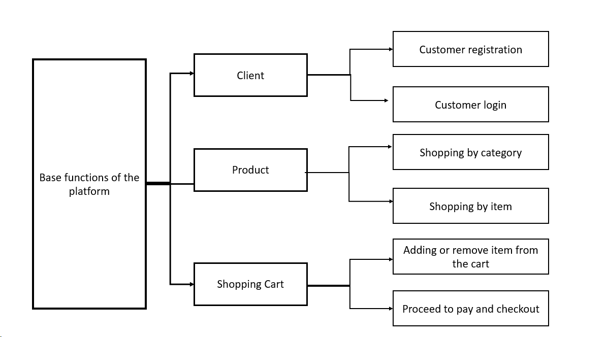

*Figure 1*

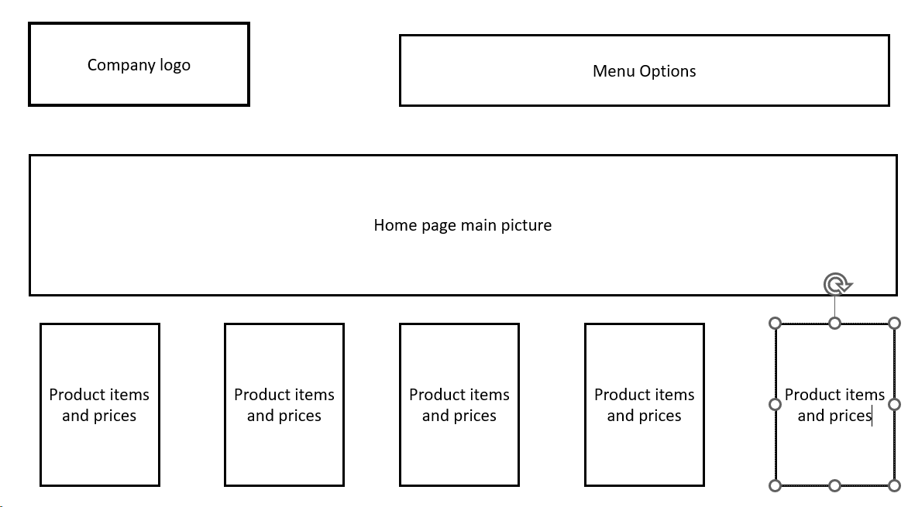

*Figure 2*

**3. Basic Template website**

**a. Screenshots of the relevant pages that have been created.**

**i) Home page**

The home page shows a company name on the top left corner of the page written in style and a few menu options on the top right corner of the page. In the background is a picture of a customer wearing one of the product items. The checkout icon is floating at the bottom right corner of every page. Again, on the right edge of the page is a navigation bar to assist customers in scrolling up and down.

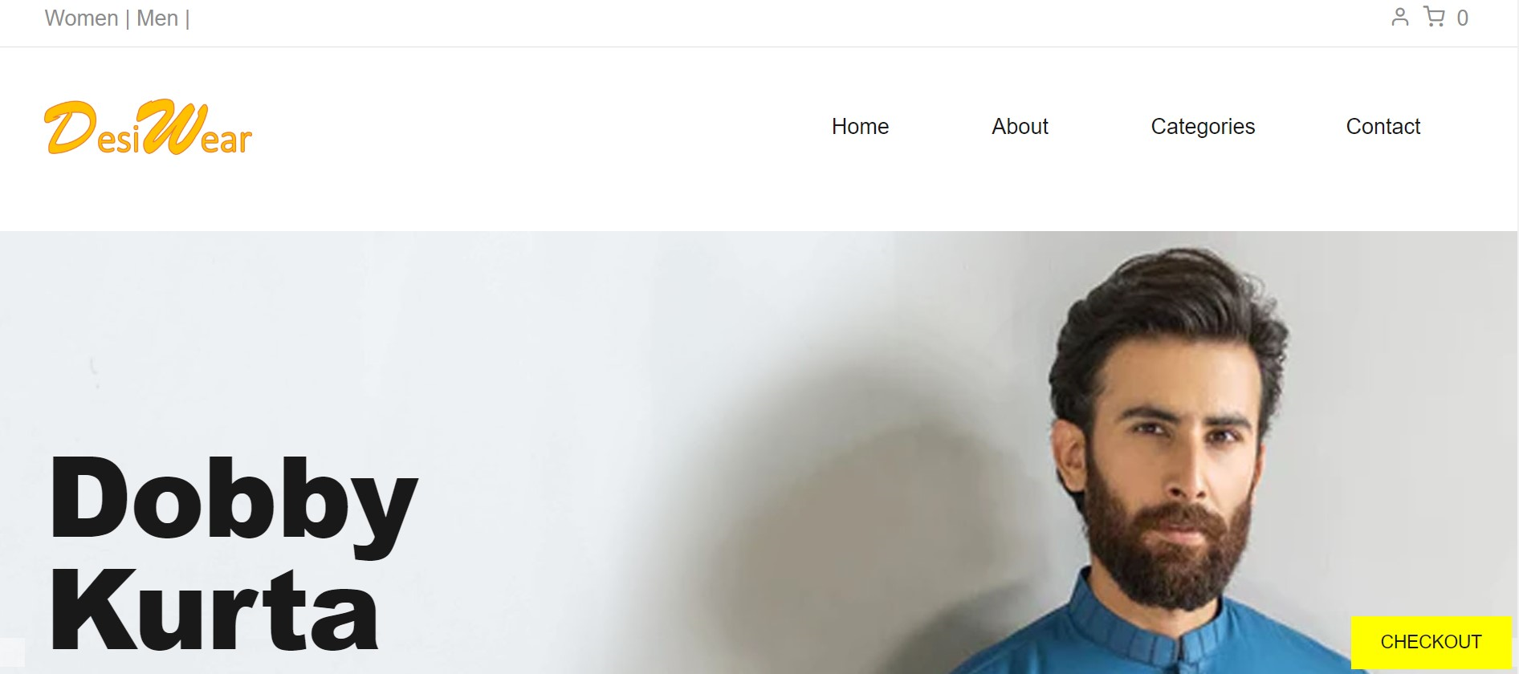

*Figure 3*

**ii) About Us page**

The About Us page gives a summary of the company indicating when it was established and also what the company is about.

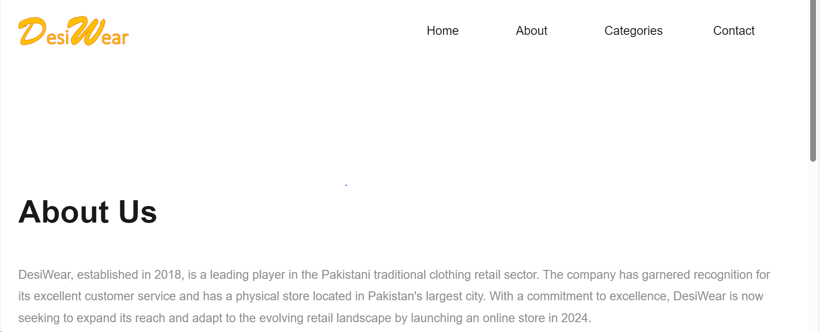

*Figure 4*

**ii) All Products**

The All Products page shows pictures of some of the available products with the pricing. Hovering on each picture brings a call-to-action feature in the form of Add To Cart which gives customers the opportunity to buy the item.

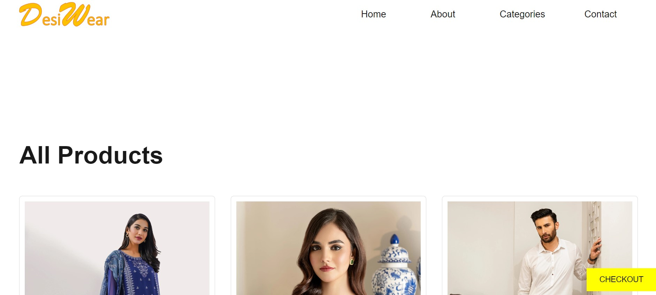

*Figure 5.*

**Screenshot 2 of the product page also shows the pricing.**

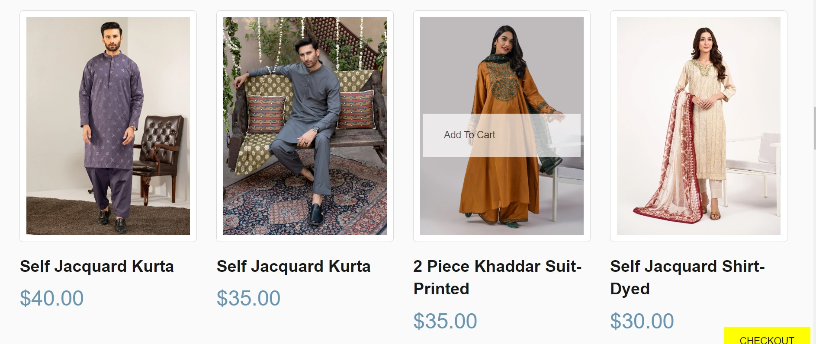

*Figure 6*

**Screenshot 3 of the product page also shows pricing.**

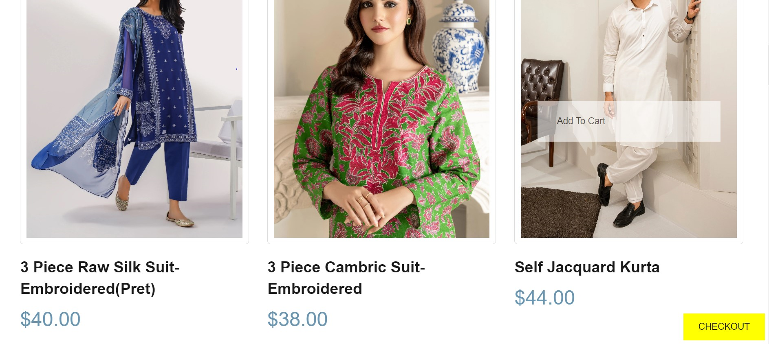

*Figure 7*

**iv) Check out Page.**

The checkout page presents an opportunity for customers to enter their card information to complete the purchasing process and confirm the purchase by clicking the checkout button.

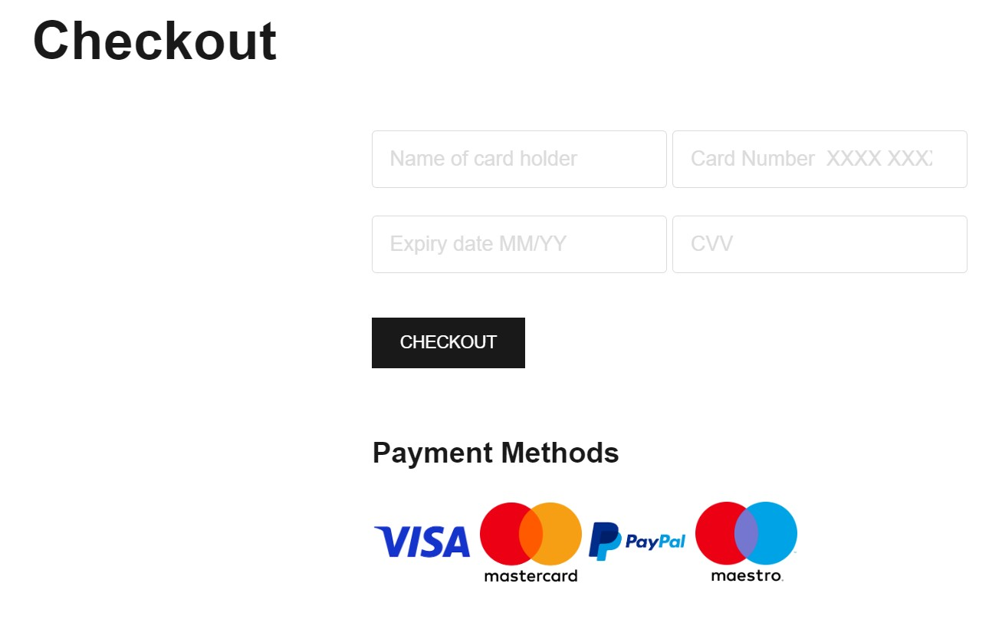

*Figure 8*

1. **Screenshot showing the Cart icon.**

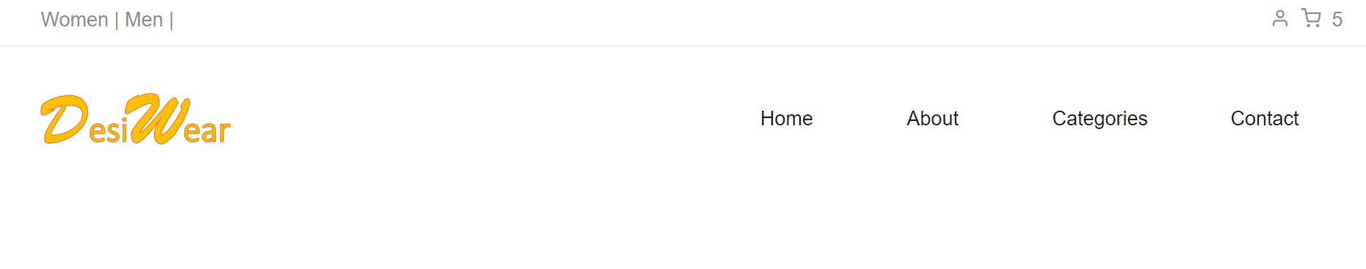

*Figure 9*

The cart icon is available at the top right corner of every page. It also shows the number of items in it. Every time the Add To Cart pop-up is clicked the number increases at the cart icon. When customers hover over each product item, the call to action Add To Cart pops up which makes it easy for the customer to select the item into the cart.

**b. Justification for the design choices**

From the onset, the aim has been to create a unique experience for customers and create an emotional feeling between the customers and the products. Hence the use of images or pictures was the preferred choice. The thinking was that the pictures would create belief and credibility of not just the product but also the company. The use of images exhibiting traditional Pakistan clothing was aimed at creating alignment with the Pakistan tradition and enticing customers to buy the products. The choice of pictures with the people wearing the attire also resonated with the dress styles of the Pakistani people and any other customers who may be interested.

**c. The website was made mobile-friendly (responsiveness)**

There have been several considerations that were incorporated to ensure that the site is mobile-friendly. Firstly, the use of blocking pop-ups was avoided as this was viewed to be disruptive and limiting visibility on small screens. The font size that was chosen is large enough to allow mobile devices to present them adequately. Responsiveness and speed were also considered as key priorities during the design phase to ensure mobile friendliness. It is also believed that the site has been made simple and the buttons are big enough the be readable by mobile devices. The auto-correct function has been switched off, especially on forms usage. This function was not fully implemented due to time constraints however it has been considered.

**4. Online Strategy**

**a. Search Engine Optimization Plan (SEO)**

Zheng (2009) defines search engine optimization as the practice of refining a website's technical layout so that its pages are easily accessible when user search queries are pushed into a web browser. The website content is also rearranged for relevancy. To enhance search optimization the DesiWear website content has been arranged into subtopics to ensure that the probability of appearing in searches or in search results is improved. Hence at the top right corner of the page, you will see menus such as Home, About, Category, and Contacts as the initial design of arranging the content into topics to improve the content search probability within organic traffic. Mobile device optimization has also been considered; however, it could not be fully implemented due to time constraints in the development of the site.

**b. Social media integration into the website.**

DesiWear ensured that it has social media accounts for most of the prominent social media platforms and made it a point that once the customer is on the company site, they can connect to their social media accounts without the need to go out of the page. Links to social media sites such as Facebook, Twitter, YouTube, LinkedIn, and Instagram are made available on the company's e-commerce page. The links are made available at the bottom of the home page of the platform. See the screenshot below taken from the home page of the site.



*Figure 10*

**References**

Combe, C. (2006). Introduction to E-Business Management and strategy (1st ed.). Taylor Francis.

Joseph, P.T. (2023). E-commerce: An Indian perspective. PHI Learning Pvt. Ltd.

Jovevski, D., Tijan, E. & Karanikić, P. (2010). Internet marketing strategies and ICT as a

common ground for business development. In The 33rd International Convention MIPRO (pp.1120-1125). IEEE.

Kutz, M. (2016). Introduction to E-commerce. Combining Business and Information Technology.

Bookboon.

Manzoor, A. (2010). E-commerce: an introduction. Amir Manzoor.

Zheng, Q. ed. (2009). Introduction to E-commerce. Springer-Verlag Berlin Heidelberg.

Murthy, C.S.V. (2007) E-Commerce-Concepts, Models and Strategies. Himalaya Publ.